**INTERNSHIP REPORT**

**ON**

# PYTHON COMPITATIVE CODEING

**A internship Report is submitted**

**In accordance with requirement of degree of**

**BACHELOR OF TECHNOLOGY**

**IN**

**Computer science and information technology**

Submitted by

**DIVYA AKKISETTY**

**21KQ1A0701**

Under the Mentorship of

## M.SRAVAN KUMAR



**DEPARTMENT OF Computer science and information technology**

PACE INSTITUTE OF TECNOLOGY AND SCIENCES

(AUTONOMOUS)

(Affiliated to Jawaharlal Nehru Technological University Kakinada, Kakinada & Accredited by NAAC ‘A’ GRADE,An ISO 9001-2015 Certified Institution)

NH-16, Valluru Post , Prakasam District, A.P-523272.

**Campus Choice Predictor**

**DESCRIPTION:**

> This project is about selecting a best campus then compared to the other colleges.

> Based on the average CGPA and placements of each and every brach.

> Which college is offered more internships.

> The college is offering more certifications,workshops.

> The college offers more extracurricular activities.

> The college has digital classrooms.

> The college has best lab facilities.

> The campus itself has comfortable hostel.

> Students at our college receive top-tier training in coding skills

**REQUIREMENTS:**

**INPUTS:**

1.College name

2. List of Branches in college

3.No.of placements

4.Pass percentage

5.Distance

6.Status

7.Transport

**OUTPUT:**

1.Details of particular college

2.College name with placements greater than 500

3.Transport available college names

4.No.of autonomous colleges

5.Branches of particular college

6.College that are less distance

7.college names with pass percentage greater than 60

8.Which college has max placements

**FUNCTIONS:**

Conditions,Lists,Sets,Dictionary,max(),pandas

## APPROACH:

## User Input:

## The code allows users to enter information for a specified number of colleges. College details include name, branches (as a list), placements, percentage, distance, status (autonomous/non-autonomous), and transport availability.

## Data Storage and Display:

## It stores the entered data in a list of dictionaries (l). The code displays the college details in a tabular format.

## DataFrame Creation:

## It creates a Pandas DataFrame (df) from the list l.

## College Search:

## It allows users to search for a specific college by name and displays its details.

## Filtering:

## It can filter colleges based on: Placements greater than 500 Transport availability ("yes") Percentage greater than 60 Autonomous status ("autonomous") 6. Analysis:

source code:

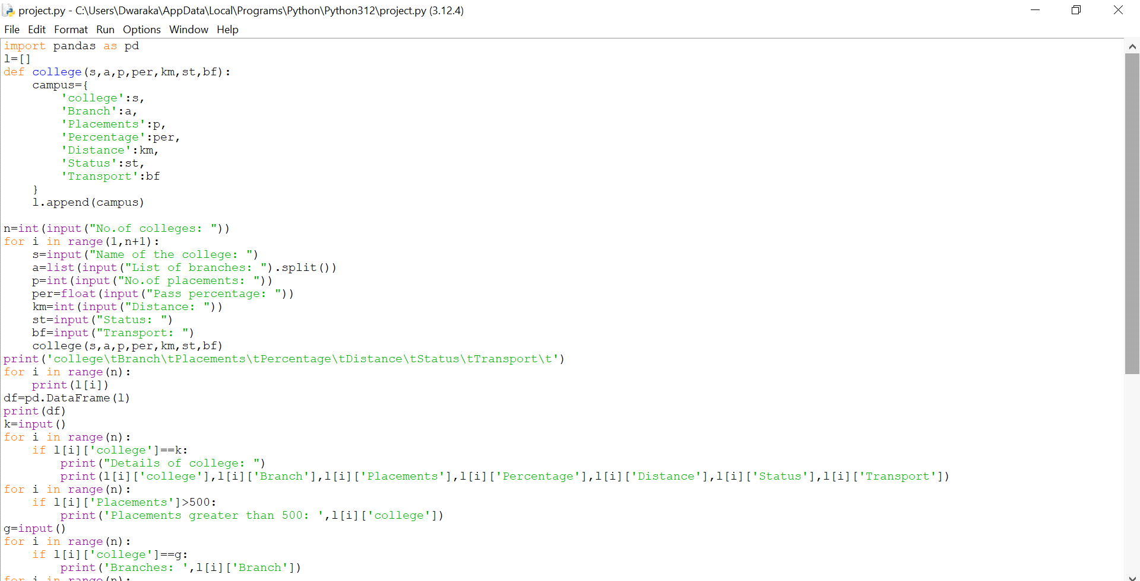

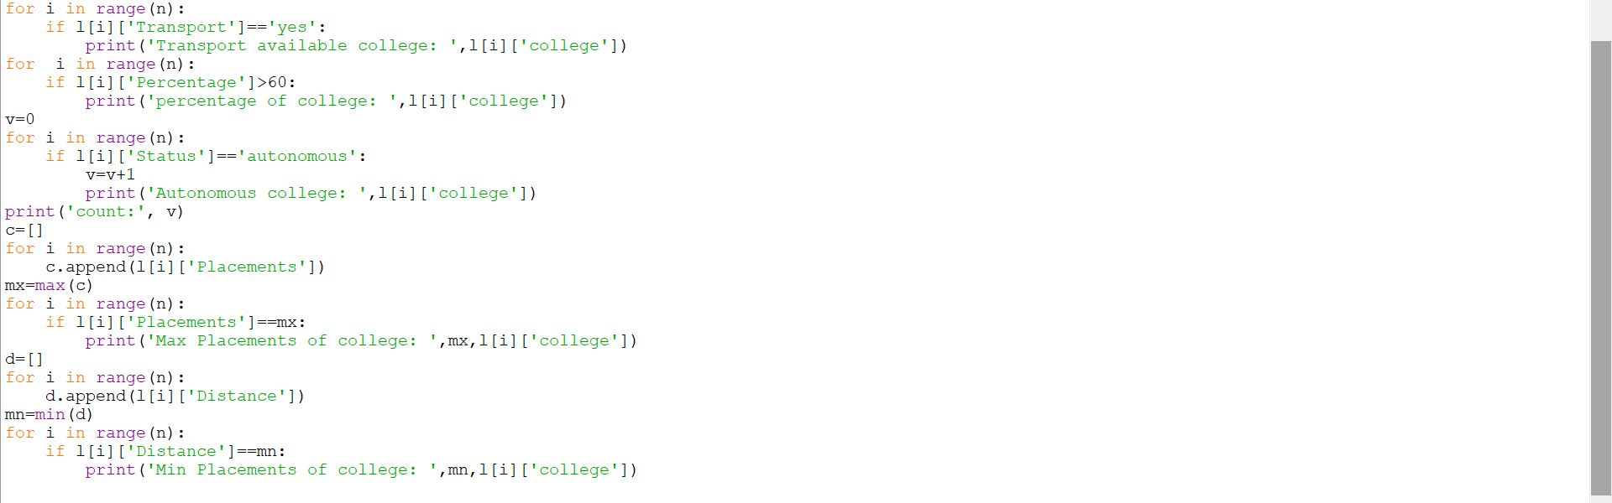

Output:

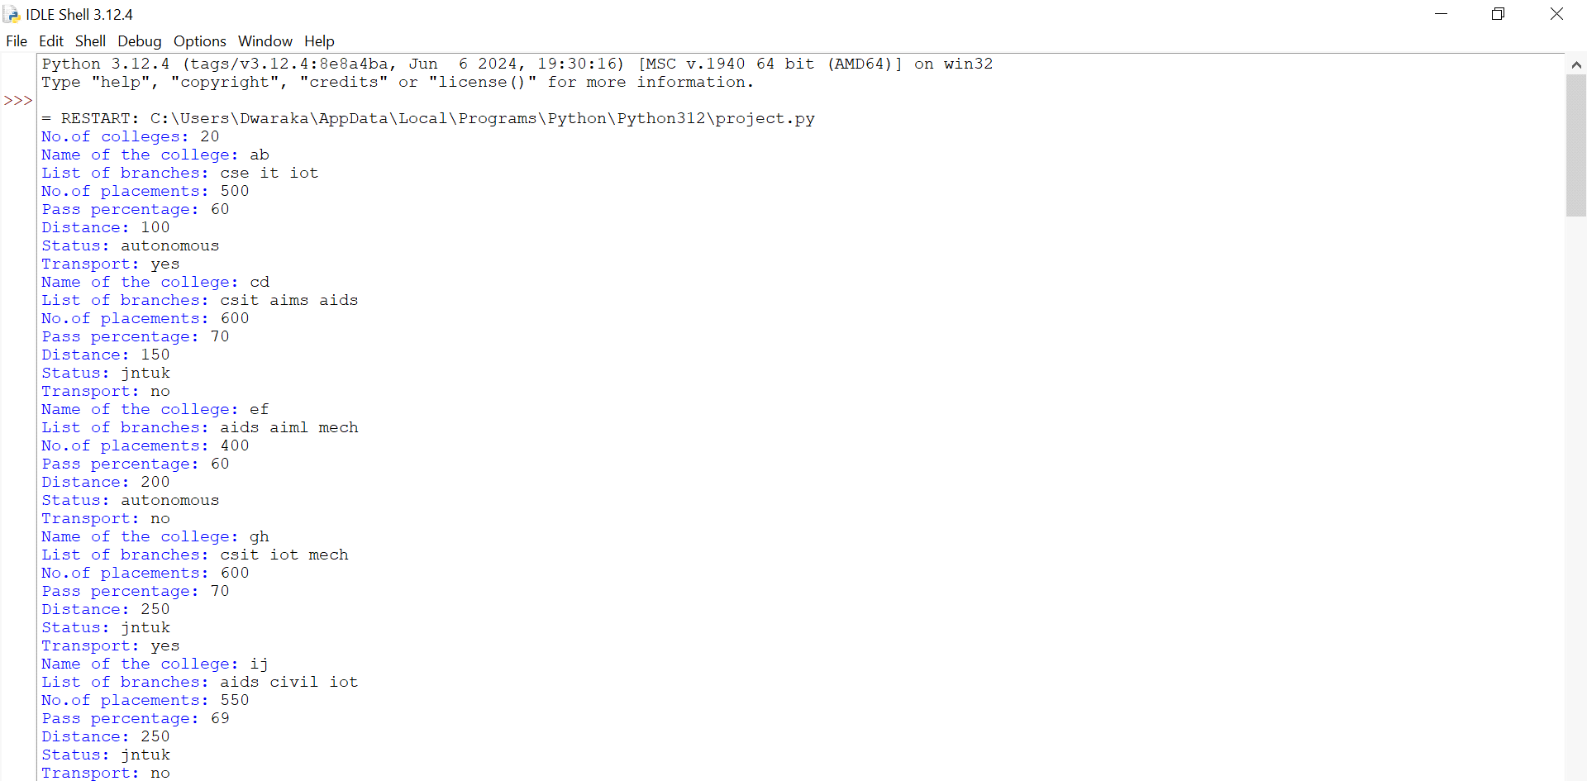

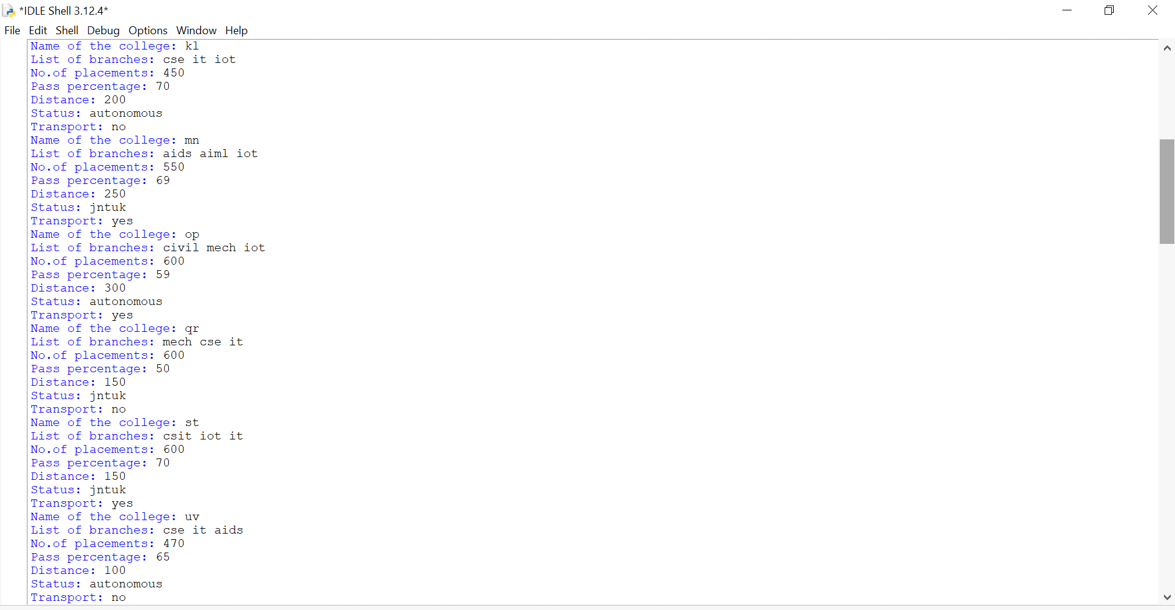

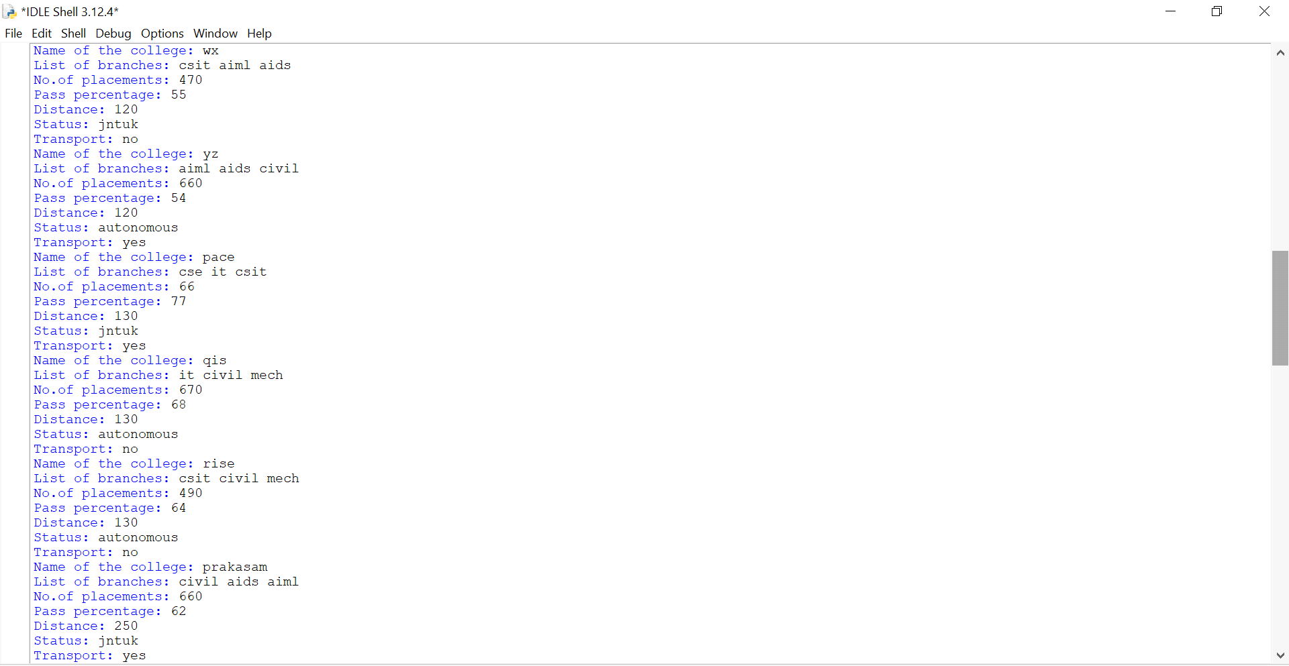

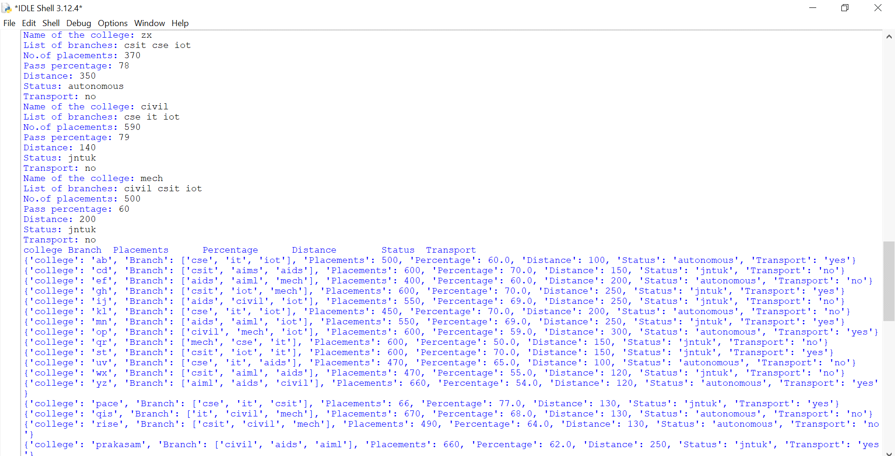

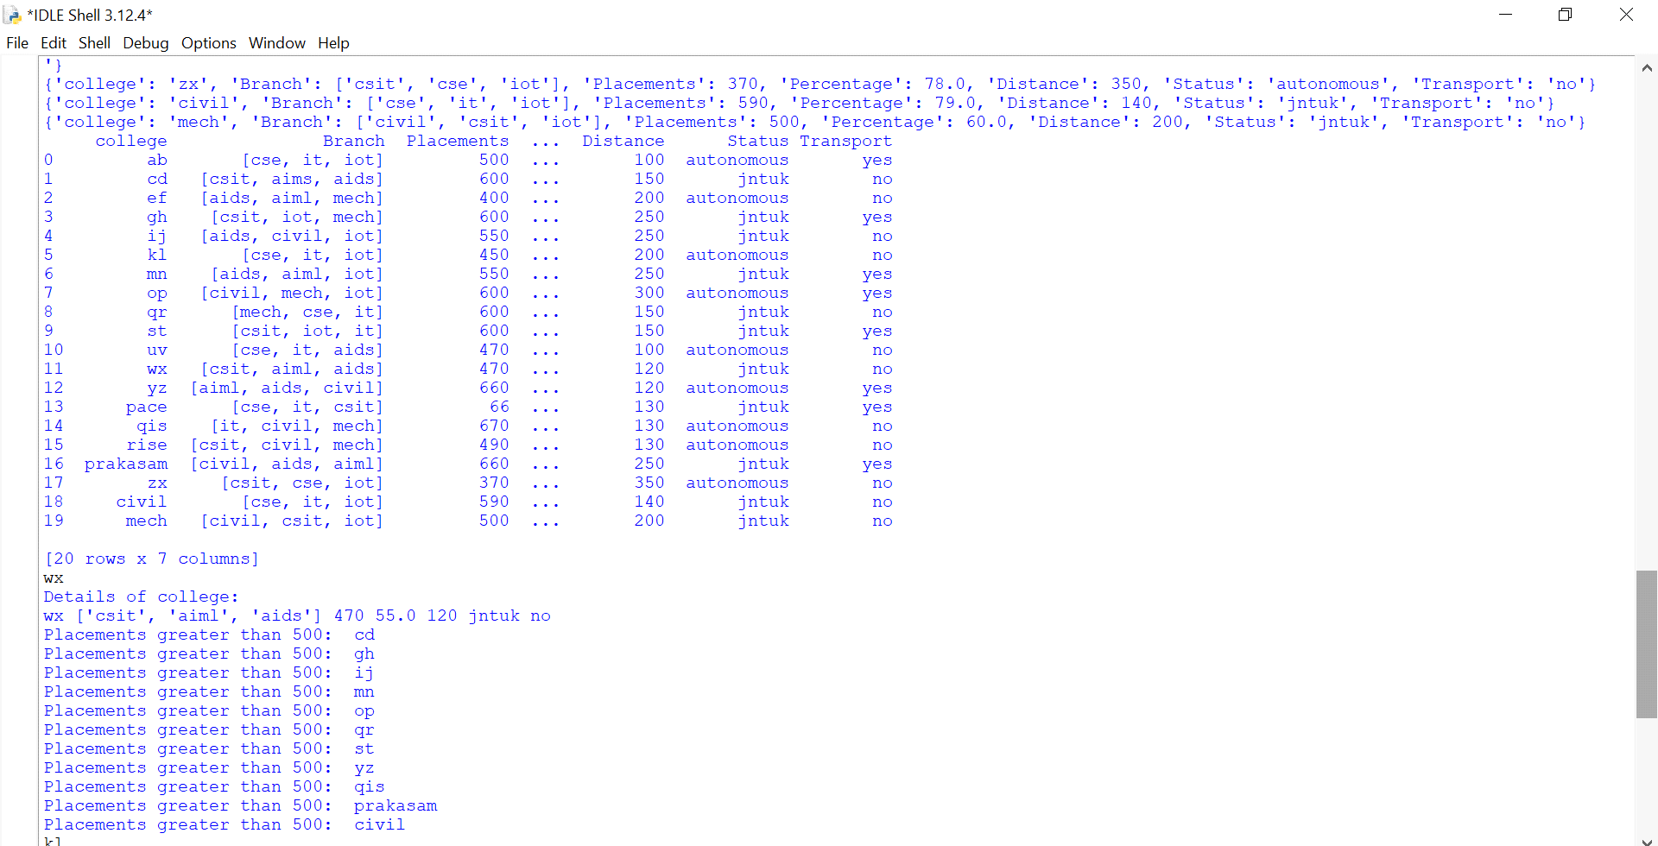

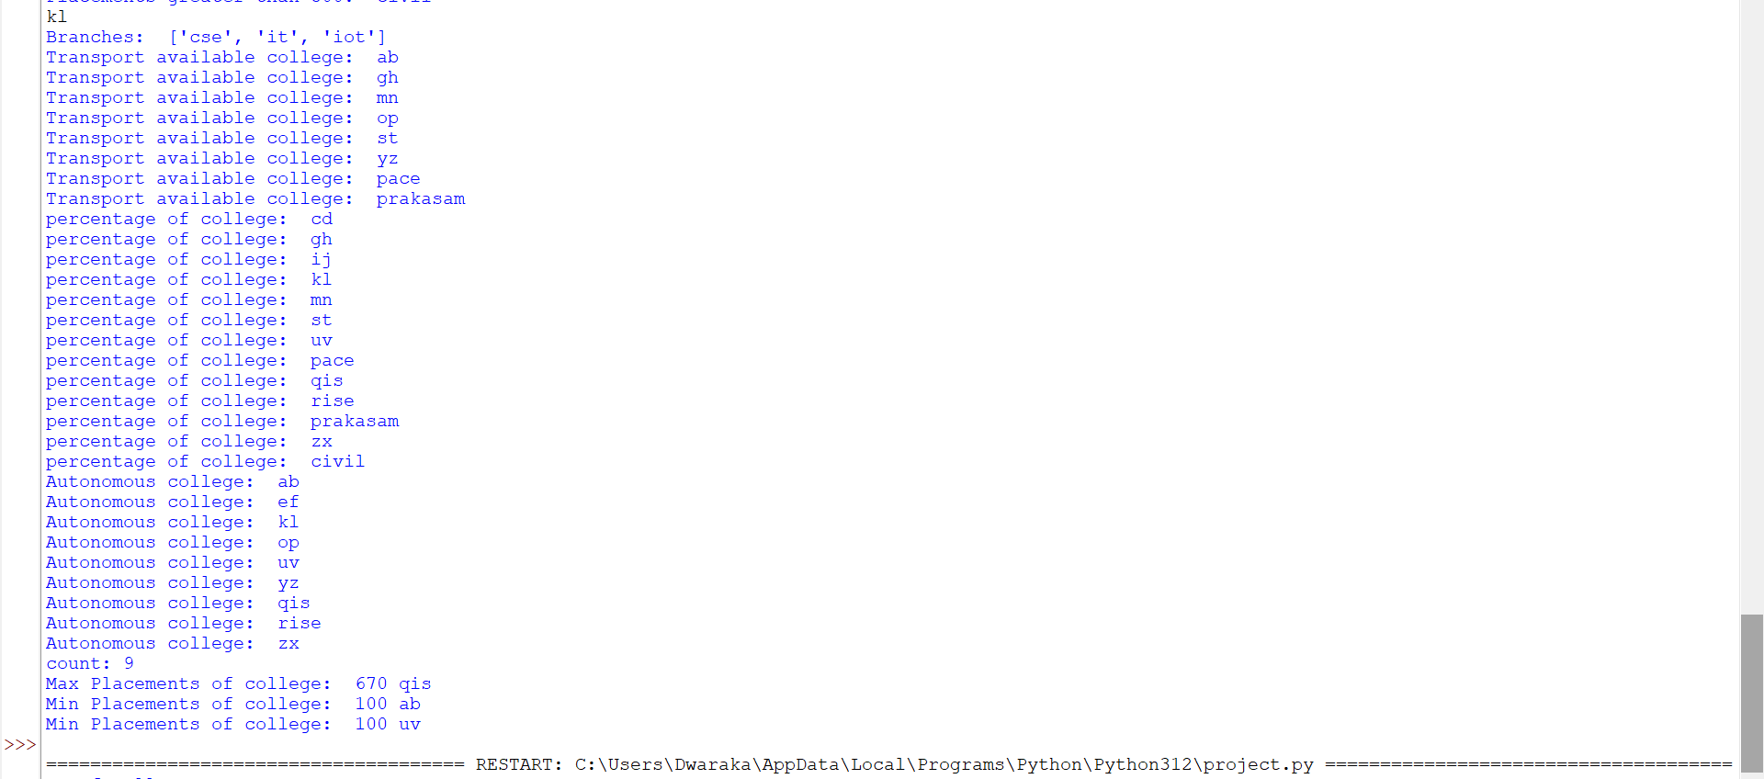

**CONCLUSION:**  
The Campus Choice Predictor, implemented entirely using Python, provides a practical tool for assisting students in selecting the most suitable college based on their individual profiles and preferences. By utilizing Python’s powerful libraries and straightforward syntax, the project achieves robust and efficient data processing, analysis, and prediction.